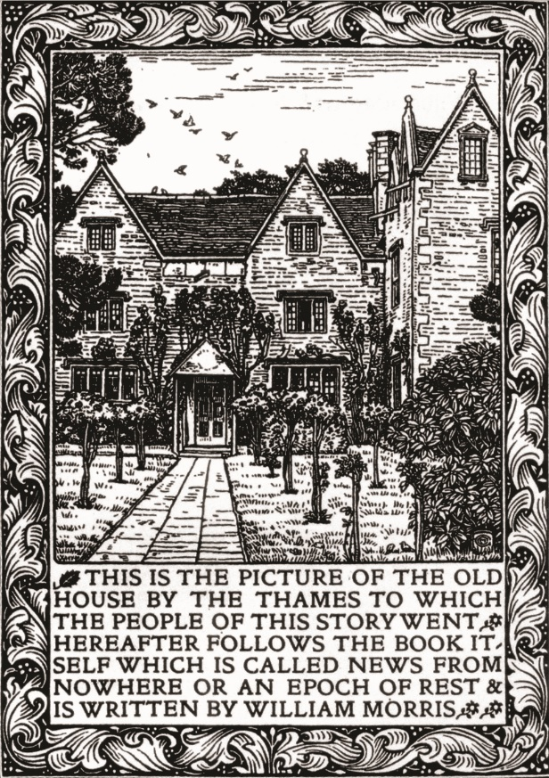 |  |  | ‘A house that I love’: William Morris and Kelmscott Manor  Exhibition at the Society of Antiquaries of London, Burlington House, Piccadilly, London W1J 0BE  9 July – 21 August 2020  SPONSORSHIP OPPORTUNITY FOR REMAINING EXHIBITION ITEMS |  | 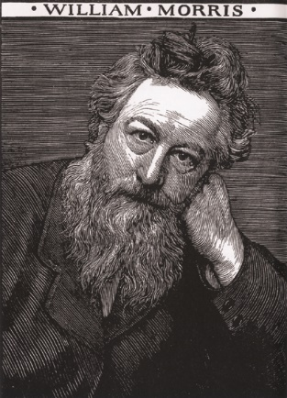
FURNITURE & TEXTILES
£2,000 | Table  designed by Philip Webb, c.1860 |  |  |  |  | 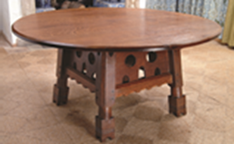
£1,250 | Armchair  designed by Philip Webb, 1862 |  |  |  |  | 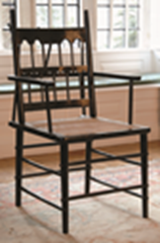
£200 | Pair of Candlesticks  designed by Philip Webb, c.1860 |  |  |  |  | 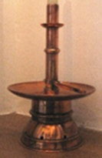
£500 | Dressing Mirror  designed by Philip Webb, c.1862 |  |  |  |  | 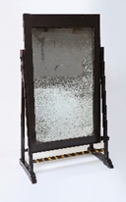
£2,000 | ‘Strawberry Thief’  printed cotton designed by William Morris, 1883 |  |  |  |  | 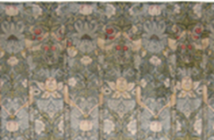
£200 | Armchair  English, 17th century |  |  |  |  | 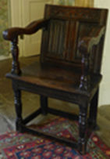
£200 | Armchair  English, 17th century |  |  |  |  | 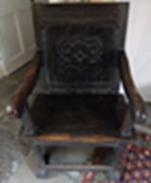
CERAMICS
£100 |  | Westerwald Stoneware Vessel  maker unknown, 19th century |  |  |  |  | 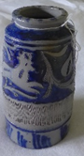
£100 |  | Westerwald Stoneware Vessel  maker unknown, 19th century |  |  |  |  | 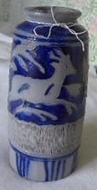
£100 |  | Dish  Fritware, Turkish, maker unknown, early 17th century |  |  |  |  | 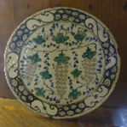

MEDIEVAL, ICELANDIC & ICELANDIC-RELATED OBJECTS
£100 | Case for Needles  Icelandic, dated 1844 | 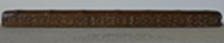
£250 | Lidded Food Bowl  Icelandic, dated 1874 | 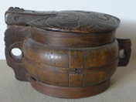
£100 | Bed Board  Icelandic, 19th century
£250 | Casket  Carved by Rikadur Jonsson, dated 1924 | 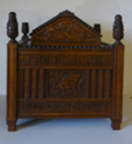
£100 | The Preface of Snorri Sturluson  calligraphic manuscript by William Morris, c.1873 | 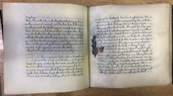
£250 | The Story of the Volsungs and the Niblungs  translated by William Morris, 1870 | 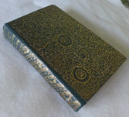

BOOKS
£500 | The Works of Geoffrey Chaucer  (Kelmscott Press 20th century)  [handling exhibit] | 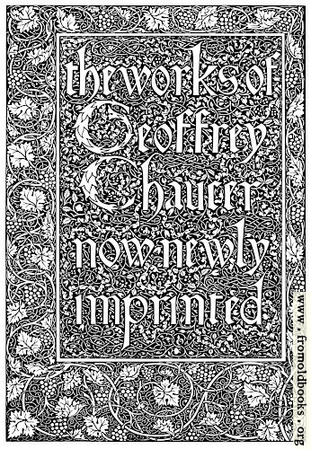
£250 | Medicinal Herbal in Six Books  by Pietro Andrea Mattioli (Venice 1583) | 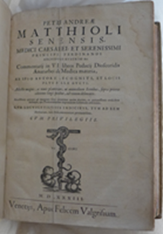
£250 | The Herball or Generall Historie of Plantes gathered by John Gerarde of London  by John Gerard (printed by Adam Islip, Joice Norton & Richard Whitakers, London 1636; first published 1587) | 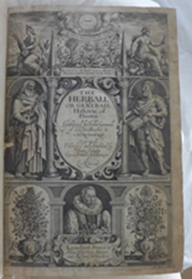

FINE ART
£1,250 | Jenny Morris (1861–1935)  pastel drawing by Dante Gabriel Rossetti, 1871 | 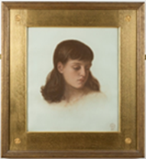
£2,500 | Spring  oil on panel by Pieter Brueghel the Younger, dated 1632 | 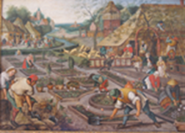
£1,250 | Jane Burden (later Morris) aged 17  pencil drawing by Dante Gabriel Rossetti, Oxford, 1857 | 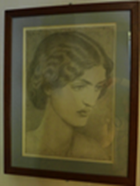
£1,000 | The Judgement of Paris  tile panel designed by Edward Burne-Jones and William Morris, 1862 | 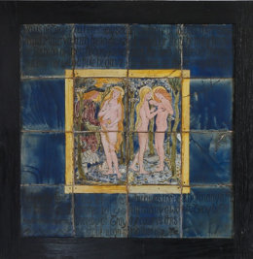
£500 | Kelmscott above the Fafnir Hedge  watercolour by Edward Scott-Snell, c.1943 | 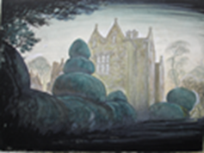
£500 | Kelmscott Manor  pen & ink drawing by Edward Scott-Snell, 1946 | 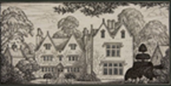
MISCELLANOUS & PERSONAL OBJECTS
£1,900 | Jewel Casket  probably designed by Philip Webb, decorated by Dante Gabriel Rossetti and Elizabeth Siddal, 1858–62 | 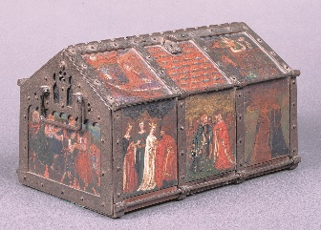
£250 | The Notebook of John Middleton FSA (1847–96)  1889 | 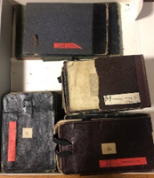
£500 | Silver Case containing a Lock of William Morris’s Hair  designed and made by Robert Catterson-Smith | 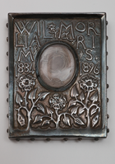
£1,000 | Poster for the Sale of Furniture & Personal Effects at Kelmscott Manor, 19 & 20 July 1939 | 